1.d.1.
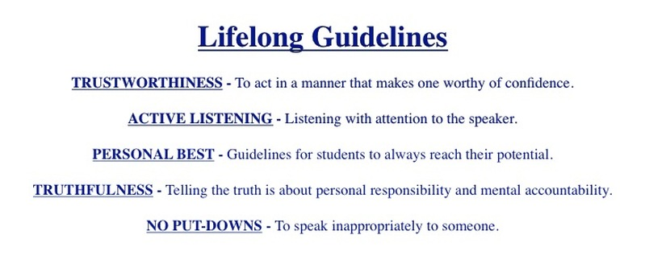
1.d.2.

SKILLS TO SUPPORT LIFELONG GUIDELINES

CARING: To show care and concern for others
COMMON SENSE: To use good judgment
COOPERATION: To work together towards a common goal (purpose)
COURAGE: To act according to one’s beliefs despite opposition
CURIOSITY: A desire to investigate and seek understanding
EFFORT: To try your hardest and do your best
FLEXIBILITY: To be willing to change plans when necessary
FRIENDSHIP: To make and keep a friend through mutual trust and caring
INITIATIVE: To do something because it needs to be done
INTEGRITY: To act according to a sense of what’s right and wrong
ORGANIZATION: To plan, arrange and implement in an orderly way; to keep things orderly and ready to use
PATIENCE: To wait calmly for someone or something
PERSEVERANCE: To continue in spite of difficulties; to keep at it
PRIDE: Satisfaction from doing one’s personal best
PROBLEM SOLVING: To seek solutions in difficult situations and everyday problems
RESOURCEFULNESS: To respond to challenges and opportunities in innovative and creative ways.
RESPONSIBILITY: To do what’s right; to respond when appropriate; to be accountable for one’s actions
SENSE OF HUMOR: To laugh and be playful without harming others

2.b.

UN Convention on the Rights of the Child, 1989

Four basic principles summarize the foundation for work with young children:
- the right to live, survival, and development;
- the right to non-discrimination;
- the best interest of the child as a primary consideration in all actions concerning child;
- the respect for the views and voices of the child.

Article 29

1. States Parties agree that the education of the child shall be directed to:

(a) The development of the child's personality, talents and mental and physical abilities to their fullest potential;

(b) The development of respect for human rights and fundamental freedoms, and for the principles enshrined in the Charter of the United Nations;

(c) The development of respect for the child's parents, his or her own cultural identity, language and values, for the national values of the country in which the child is living, the country from which he or she may originate, and for civilizations different from his or her own;

(d) The preparation of the child for responsible life in a free society, in the spirit of understanding, peace, tolerance, equality of sexes, and friendship among all peoples, ethnic, national and religious groups and persons of indigenous origin;

(e) The development of respect for the natural environment.

COUNCIL RECOMMENDATIONS of 9 December 2013 on effective Roma integration measures in the Member States

Access to education
1.3. Take effective measures to ensure equal treatment and full access for Roma boys and girls to quality and mainstream education and to ensure that all Roma pupils complete at least compulsory education. This goal could be attained by means of measures such as measures:
(a) eliminating any school segregation;
(b) putting an end to any inappropriate placement of Roma pupils in special needs schools;
(c) reducing early school leaving ( 1 ) throughout all levels of education, including at secondary level and vocational training;
(d) increasing the access to, and quality of, early childhood education and care, including targeted support, as necessary;
(f) using inclusive and tailor-made teaching and learning methods, including learning support for struggling learners and measures to fight illiteracy, and promoting the availability and use of extracurricular activities;
(g) encouraging greater parental involvement and improving teacher training, where relevant;
(h) encouraging Roma participation in and completion of secondary and tertiary education;
(i) widening access to second-chance education and adult learning, and providing support for the transition between educational levels and support for the acquisition of skills that are adapted to the needs of the labour market.

COUNCIL OF EUROPE COMMITTEE OF MINISTERS
Recommendation No R (2000) 4 of the Committee of Ministers to member states on the education of Roma/Gypsy children in Europe
(Adopted by the Committee of Ministers on 3 February 2000 at the 696th meeting of the Ministers' Deputies)

I. Structures

4. In order to secure access to school for Roma/Gypsy children, pre-school education schemes should be widely developed and made accessible to them.

II. Curriculum and teaching material

8. Educational policies in favour of Roma/Gypsy children should be implemented in the framework of broader intercultural policies, taking into account the particular features of the Romani culture and the disadvantaged position of many Roma/Gypsies in the member states.

9. The curriculum, on the whole, and the teaching material should therefore be designed so as to take into account the cultural identity of Roma/Gypsy children. Romani history and culture should be introduced in the teaching material in order to reflect the cultural identity of Roma/Gypsy children. The participation of representatives of the Roma/Gypsy community should be encouraged in the development of teaching material on the history, culture or language of the Roma/Gypsies.

III. Recruitment and training of teachers

13. It is important that future teachers should be provided with specific knowledge and training to help them understand better their Roma/Gypsy pupils. The education of Roma/Gypsy pupils should however remain an integral part of the general educational system.

14. The Roma/Gypsy community should be involved in the designing of such curricula and should be directly involved in the delivery of information to future teachers.

15. Support should also be given to the training and recruitment of teachers from within the Roma/Gypsy community.

COUNCIL OF EUROPE COMMITTEE OF MINISTERS
Recommendation CM/Rec(2009)4 of the Committee of Ministers to member states on the education of Roma and Travellers in Europe
(Adopted by the Committee of Ministers on 17 June 2009 at the 1061st meeting of the Ministers’ Deputies)

II. Structures and provision for access to education

10. Attendance of preschool education for Roma and Traveller children should be encouraged, under equal conditions as for other children, and enrolment in preschool education should be promoted if necessary by providing specific support measures.

11. Access of Roma and Traveller children to compulsory education should be facilitated and subject to the same criteria as the majority population, with particular emphasis on the transition from preschool to primary education, and from primary to secondary education. Special provisions for preventing school drop out and stimulating the return to school of those who did not finish compulsory education should be made available.

14. Schools should make strong efforts to engage Roma and Traveller parents in school-related activities in order to enhance mutual understanding. When involving parents, the school must respect their values and culture and acknowledge their contribution to the education of their children.

15. School mediators and/or assistants recruited from Roma and Traveller communities should be employed to facilitate the relations between teachers and Roma or Traveller families, as well as between schools and the Roma or Traveller community. They should be provided with adequate training and support and be accepted as far as possible as full members of the school’s professional team.

III. Curriculum, teaching material and teacher training

16. Intercultural learning and combating racism and discrimination should be explicitly recognised as priorities of the education process and should be a key element of school ethos. Curriculum, textbooks and other support materials should promote intercultural dialogue and raise awareness on stereotypes, prejudices and discrimination in general including against Roma and Travellers.

19. Educational authorities should ensure that all teachers, and particularly those working in ethnically mixed classes, receive specialised training on intercultural education, with a special regard to Roma and Travellers. Such training should be included in officially recognised programmes and should be made available in various forms, including distance and online learning, summer schools, etc.

20. Teachers working directly with Roma and Traveller children should be adequately supported by Roma or Traveller mediators or assistants and should be made aware that they need to engage Roma and Traveller children more in all educational activities and not de-motivate them by placing lower demands upon them and encourage them to develop their full potential.

21. Good practices based on an integrated whole-school approach, including training for school managers, teachers, mediators or assistants, activities targeting parents, measures to stimulate school participation at all levels, to prevent and combat segregation and discrimination in general, and to promote effective intercultural dialogue in the local community, should be taken as references and expanded

2.f.
BLAME THE VICTIM THEORY
(Ryan, 1976)

Blame the Victim Theory places causes of social problems in one’s suffering, its consequences, and not in characteristics of living conditions. Problems are explained/solved without changing the conditions that create them. Blaming the victim is widespread and often used unconsciously.

STEPS:

1. DEFINING THE PROBLEM AND THE POPULATION AFFECTED BY IT
For example: Roma children are unsuccessful in school and often drop out.

2. COMPARING THE VALUE SYSTEM, CULTURE AND SPECIFIC BEHAVIOR OF THE POPULATION THAT HAS A PROBLEM WITH THE ONE THAT DOES NOT/often based on stereotypes
For example: Roma value freedom, they are not used to working, they do not care for education, children are ‘educationally neglected.’

3. PLACING THE CAUSE OF THE PROBLEM IN THE DIFFERENCES THAT EXIST BETWEEN THESE TWO POPULATION
For example: Roma children have problems because their parents do not care about them getting an education - it is not taken into account that parents are illiterate, that they do not see any sense in educating their children since they will not be able to find a job, that they do not have money for books and clothes.

4. STARTING ACTIONS THAT CHANGE THE AFFECTED POPULATION - FAMILY RELATIONS, THEIR LANGUAGE, CULTURE, CUSTOMS ARE BARRED AND THEY ARE TAUGHT THE BEHAVIOR CHARACTERISTIC FOR THOSE WHO ‘DO NOT HAVE THIS PROBLEM’
For example: Roma children are enrolled in special schools, parents are pressured to send children to school, but it is not taken into account that children do not speak the language in which they are being tested and taught.

3.a.
GLOSSARY

1. Affirmative Action is the vehicle for providing support for the institutional participation of subordinate group members. Affirmative Action provides support that allows the subordinate group access to jobs, education, and/or political participation. In East Central and South Eastern Europe, Affirmative Action is sometimes referred to as “Positive Discrimination.”
2. Anti-bias Education (Education for Social Justice) is an active/activist approach to challenging prejudices and stereotypes. In any society, institutions can create and maintain oppressive structures. It is not sufficient to say one is not prejudiced and to stand by as an observer. It is necessary for each individual to actively intervene, challenge, and counter the personal and institutional behaviors that perpetuate oppression.
3. Ableism is an attitude, action, or institutional practice backed by institutional power that subordinates people because of their physical disability.
4. Ageism is an attitude, action, or institutionalized practice backed by institutional power that subordinates people based on their age (either they are considered too old or too young).
5. Ally refers to a person from the dominant/non-target group who actively supports people from the subordinate/target group. An ally takes action to stop oppression without regard for his or her own position in society.
6. Anti-Semitism is an attitude, action, or institutional practice backed by institutional power that subordinates people because of their Jewish heritage.
7. Assimilation is a process whereby a minority group gradually adopts the language, customs, attitudes, and values of the prevailing culture, thereby relinquishing or abandoning their own.
8. Bias is an attitude or set of beliefs that justify the unfair treatment of an individual or a member of a particular group. This attitude usually manifests itself in the inferior treatment of members of a subordinate/target group.
9. Classism is an attitude, action, or institutional practice backed by institutional power that subordinates people because of characteristics that are not valued by the dominant society and is often related to socio-economic standing.
10. Discrimination is the manifestation of prejudice in action. Discrimination can be against an individual or group because of characteristics, including but not limited to, heritage, race, class, gender, age, physical ability, religious beliefs, or sexual orientation.
11. Dominant Group/Non-target Group is the group that holds the power in any relationship. The dominant group intentionally or unintentionally exploits, mistreats, demeans, or destroys a subordinate/target group.
12. Education for Social Justice is an alternative term to anti-bias education. Its meaning is the same.
13. Ethnic Minority is a term used to refer to people belonging to a racial group that is different from the majority. Ethnicity is often associated with culture, religion, and physical difference.
14. Equity is the differential treatment of groups or individuals according to their needs. Equity promotes fairness through differentiation of action rather than through uniformity of action.
15. Equality is the concept that all people are equally valued, receive equal treatment, and have the same opportunities.
16. Heterosexism is an attitude, action, or institutional practice based by institutional power that favours people of heterosexual orientation over those of homosexual orientation.
17. Homophobia is an attitude, action, or institutional practice backed by institutional power that subordinates people because of their homosexual orientation.
18. Inclusion is a philosophy or value system which holds that all people are entitled to equitable access. The term is often used regarding students’ access to learning, achievement and pursuit of excellence in all aspects of their education. The philosophy of inclusion transcends the idea of physical location and incorporates basic values that promote participation, friendship, and social interaction which result in a sense of belonging.
19. Institutionalized Oppression is the unfair social, legal, economic, and institutional practices perpetuated by the dominant group against the subordinate/target group.
20. Internalized Oppression is the erroneous belief a subordinate/target group has internalized about itself, based on the mistreatment and misinformation it has received from the dominant/non-target group. The target group actually believes the views of the dominant/non-target group as a result of long term institutionalized racism and bias.
21. Internalized Domination is the erroneous belief of supremacy that a dominant group has internalized about itself, based on misinformation, power, and privileges, which are inherent in the attitudes and behaviours within social and institutional structures.
22. Linguicism or Linguistic Oppression is an attitude, action, or institutionalized practice, backed by institutional power that subordinates people because of the language they speak.
23. Multicultural Education is an approach that enables students to understand, respect, and appreciate cultural differences and similarities, as well as recognize the accomplishments of diverse ethnic, racial, and socio-economic groups. Diverse groups are portrayed realistically and from a variety of perspectives with the purpose of equalizing cultural relations. Multicultural education can be implemented at a wide range of levels beginning with having students celebrate ethnic diversity through ‘foods, fun, and festivals’ to a more ‘transformative’ approach that weaves a range of cultural perspectives throughout the curriculum with the aim of developing a socially just society.
24. Oppression is the systematic exploitation of one social group by another for its own benefit. For an action to be considered oppression, it must have the following three components: 1) be in the national consciousness; 2) represent an imbalance of power; 3) be institutionalized. The phenomenon involves institutional control, ideological domination, and the dissemination of the dominant group’s culture on the oppressed.
25. Pluralism is a social system based on the premise that all groups have a right to maintain their language and culture in order to create a society reflective of the diversity that exists.
26. Prejudice is an attitude, opinion, or feeling formed without adequate prior knowledge, thought, or reason. Prejudice is a prejudgment for or against any person or group. Prejudice is often based on lack of information or information that is partly true but which misconstrues the facts.
27. Racism is an attitude, action, or institutional practice backed by institutional power that subordinates people because of their skin color or ethnic origin. This includes the imposition of one group’s culture in such a way as to withhold respect for, demean, or destroy the cultures of other groups. Racism provides the dominant group with self-confidence that is based not on real but on assumed superiority over other groups: Racism = Prejudice + Power.
28. Re-stimulation occurs when an experience triggers memories or past hurts or mistreatments, resulting in a strong emotional reaction. People who experience layers of hurt and mistreatment without releasing or discharging them sometimes rely on negative patterns of behaviour that have worked for them in the past. Restimulation limits the person’s ability to be in the present with an issue, to think clearly, and to find solutions to life’s problems.
29. Segregation is the enforced separation of subordinate groups in a country, community, or institution.
30. Sexism is an attitude, action, or institutional practice backed by institutional power that subordinates people because of their gender.
31. Sizism is an attitude, action, or institutional practice backed by institutional power that subordinates people because of their physical size.
32. Social Justice is the general socio-ethical principle. This includes values ​​such as equal rights, human dignity, social solidarity, etc. Social Justice means a relatively equal distribution of resources among all members of society to respond to the needs. Implementation of social justice is the process of creating an equitable society through challenging prejudices, stereotypes, and the institutions that create and maintain oppressive structures in a society.

33. Stereotype is an oversimplified generalization about a particular group which almost always carries with it derogatory implications.
34. Subordinate Group/Target Group is a group of people who are systematically excluded, demeaned, exploited, and/or mistreated by the dominant group in a society.
35. Voice is the notion that those who are traditionally silenced and/or disempowered become actively involved through dialogue and action. Having voice suggests meaningful input leading to a sense of ownership and empowerment.
36. White Supremacy is a belief in the superiority of white people over people of colour, including the right of white people to keep others in subordinate roles.

3.b.
SOCIAL JUSTICE

Social Justice is the general socio-ethical principle. This includes values ​​such as equal rights, human dignity, social solidarity, etc.

Social Justice means a relatively equal distribution of resources among all members of society to respond to the needs.

Implementation of social justice is the process of creating an equitable society through challenging prejudices, stereotypes, and the institutions that create and maintain oppressive structures in a society.

Social justice as goal:
- Full and equal participation of all groups in a society
- Distribution of resources is equitable and all members are physically and psychologically safe and secure
- Individuals are both self-determining and interdependent
- Social actors with sense of their own agency and sense of social responsibility toward others and society as a whole

Social justice as process:
- Democracy
- Participation
- Inclusion
- Affirmation of human agency and human capacities for working collaboratively to create change

Education for Social Justice is an active approach to challenge prejudices and stereotypes. It is not sufficient to say one is not prejudiced and to stand by as an observer. It is necessary for each individual to actively intervene, challenge, and counter the personal and institutional behavior that perpetuates oppression.

Outcomes for Education for Social Justice
- Increased knowledge, understanding, and sensitivity of mechanisms which perpetuate and maintain systems of domination,
- Commitment to the process of building capacity for personal, professional, and institutional transformation.

Inclusion is a philosophy or value system which holds that all people are entitled to equitable access. The term is often used regarding students’ access to learning, achievement and pursuit of excellence in all aspects of their education. The philosophy of inclusion transcends the idea of physical location and incorporates basic values that promote participation, friendship, and social interaction which result in a sense of belonging.

3.c.
SOCIAL OPRESSION MATRIX

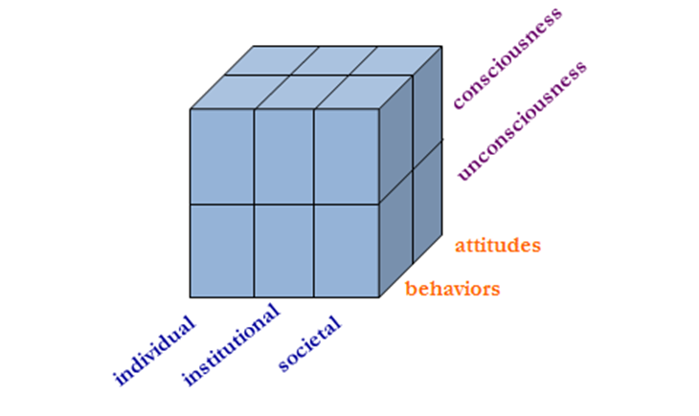
The Context

- Individual level - refers to actions or attitudes of individual that maintain oppression
- Institutional level - Focus is on institutions that maintain and perpetuate system of oppression
- Societal/Cultural level
- cultural norms that perpetuate implicit and explicit values
- cultural perspective of the dominant group that is imposed on institutions by individuals and on individuals by institutions
- cultural guidelines: philosophies of life, definitions of the good, normal, health, deviance, etc – served for the justification of social oppression.
- foundation of all the “isms”, as well as the internalized oppression/ domination.
- hegemony - maintained through “regimes of truth” (Foucault)

The Psycho-Social Processes

- Conscious processes - knowingly supporting the maintenance of social oppression through individual, institutional and cultural/societal attributes.
- Unconscious processes - unknowing or naive collusion with the maintenance of social oppression; occur when the target or agent comes to accept the dominant logic system and justifies oppression as normal part of the natural order.

The Application

- Attitudinal level - individual and systemic values, beliefs, philosophies and stereotypes that feed the system of oppression
- Behavioural level - actions of individual and systems that support and maintain social oppression
4.b. CULTURE BINGO

Instructions
Each square on the card can tell us something new about the seminar participants even those whom it seems we know well.
Interview the participants and if any of the following points applies to the member you are talking to, please, ask him/her to enter his/her name in the appropriate square. Invite this person to tell what he/she knows about the issue where he/she has written his/her name.

IMPORTANT: Though a person could enter his/her name in several squares, he/she is allowed to enter it ONLY IN TWO SQUARES.

Remembers a fairy-tale from childhood | Knows who is Zorya | Knows when Roma people celebrate the New Year | Country famous with Lake Blade and town with the same name. | Knows which was the European Capital of Culture in 2014.
Knows the father’s name of any of the present persons | Has been in a country outside the EU | Speaks four languages | Knows when the New Year starts according to the Chinese calendar | Knows what OKSFAM means
A person who is present and who has a younger sister. | Knows the international country phone code of the Czech Republic | Knows how many countries bordering Slovakia | Knows the country which is called the cradle of democracy. | The country where in 1906 everybody (including women) had equal rights to parliamentary elections. At that time, it was a unique case in Europe.

4.c.1. STEREOTYPES AND PREJUDICE
STEREOTYPE is an oversimplified generalization about a particular group which almost always carries with it derogatory implications. Stereotyping helps us make sense of the world around us in a situation which is not clear to us (i.e., in which we do not possess sufficient information). Stereotypical thinking ‘fills the gaps’ – completes deficient information – thereby giving us a false sense of certainty, safety, and clarity.

Functions of stereotypes
Stereotypes help us:
- Make sense and understand the world around us (in a situation which is not clear enough, i.e. in which we do not possess sufficient information, stereotypical thinking “fills the gaps”, completes deficient information and gives us sense of certainty, safety and clarity).
- Evaluate the group we belong to.
- Evaluate other groups, their characteristics and ways of functioning.
Justify discrimination of those who belong to other groups.

Ethnic distance and ethnic stereotypes could be viewed as forms and indicators of prejudice.

Social psychology defines PREJUDICE as a specific type of attitude:
- Judgments that are not based on factual and logical arguments
- That are resistant to change
- That include strong emotional relations

G. Allport – Types/ Degrees of Prejudice
- gossip and stereotypical judgment (dirty, ugly, evil)
- social distance - avoiding contact
- discrimination – limitation of various rights
- physical assault – transition from verbal to physical aggression
- genocide – elimination

ATTITUDES are relatively enduring subjective (+ or -) relations to certain objects (groups, nations, individuals, institutions...). Data are distorted and adjusted to prejudice, interpreted in accordance with them. Each attitude consists of three components:
- cognitive (what we think)
- affective (what we feel)
- behavioral/connative (what we do)

Process of Forming Stereotypes and Prejudice
Three Steps:
1. Creating “conspicuous” categories - when we meet people, we focus on the most "conspicuous" characteristics, neglecting other.
2. Making incorrect generalizations about a group (stereotype and prejudice) – on the basis of these conspicuous attributes we make conclusions about a person and generalize it to the groups he/she belongs to. Prejudice and stereotypes lead to untrue generalizations about individuals when we believe that the groups they belong to are homogenous. This way of thinking denies the right to differ. When the reality is not in compliance with the prejudice and stereotypes we have, we tend to “falsify reality” in order to preserve what we want to believe in.
3. Treating people differently in accordance with these conclusions (discrimination).
4.c.2.

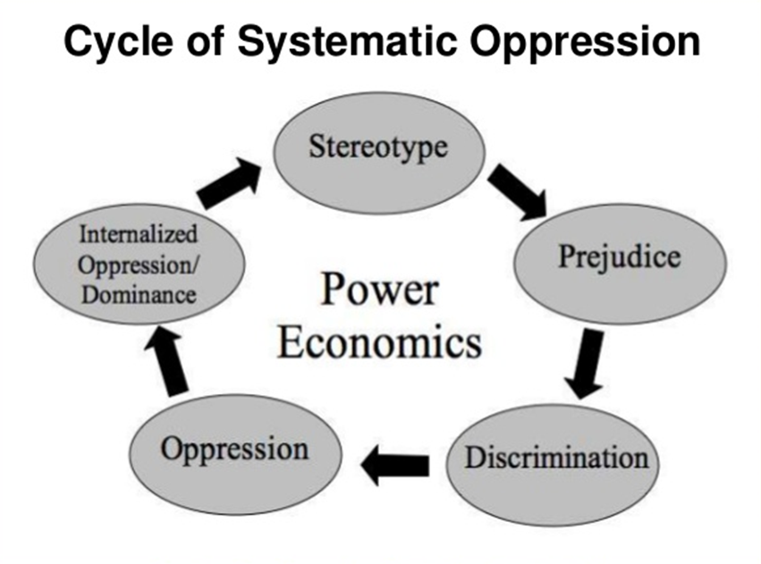

5.a.

RISK FACTORS IN INTERCULTURAL LEARNING

1. Risk of Self-Disclosure
- Fear of revealing own weakness
- Fear of becoming vulnerable

2. Risk of Self-Awareness
- Fear of comparing ourselves with the others

3. Risk of Failure
- Fear of failing to integrate different cultural values

4. Risk of Identity Loss
- Fear of losing specific features of own culture
- Fear of jeopardizing own group identity

5. Risk of Alienation
- Fear of alienation and/ or rejection from our own group

6. Risk of Being Marginalized
- Fear of marginalization of our
- Fear of marginalization within our own group

7. Risk of Embarrassment and Humiliation
- Fear of embarrassment and humiliation when in contact with other groups/cultures
- Fear of rejection

8. Risk of Personal Change and Growth
- Fear of leaving old, familiar patterns of behaviour
- Fear of establishing new ways of functioning
- Fear of losing personal identity and balance

9. Risk of Emotional Stress
- Fear of losing inner peace and balance
- Fear of losing control over situation

10. Risk of Ambiguity
- Fear of uncertainty

5.b.
NEEDS INVENTORY
Integrity | Order | Protection
Autonomy | Rest | Beauty
Learning | Authenticity | Inspiration
Peace | Freedom | Balance
Creativity | Development | Love
Diversity | Meaning | Closeness
Play | Spontaneity | Exchange
Participation | Expression | Clarity
Joy | Touch | Celebration
Understanding | Respect | Warmth
Responsibility | Acceptance | Recognition
Appreciation | Empathy | Support
Empowerment | Trust | Honesty
Change | Novelty | Happiness
Protection | Creativity | Enrichment of life
Belonging | Harmony | Instigation
Gratitude | Warmth | Mutuality
Openness | Free choice | Sharing
Sex | Movement | Food
Rest | Water | Health

M.Rosenberg, Center for Non-violent Communication, Sherman, Texas.

5.c.1.

BASIC PRINCIPLES OF WORK ON PREJUDICE and DISCRIMINASTION
- »Isms« are learned patterns of thinking and behaviour, consciously or unconsciously transmitted through the institutions of the system that children adopt as their own and as truth.

- »Ism« is a prejudice against a group of people, or individuals that is supported, or sanctioned, or legalized and backed by the institutions of the system.

- Research shows that complete unlearning of prejudice is impossible, but that it is possible to develop abilities to re-examine stereotypes and negative information that are in the basis of prejudice.

- In work on prejudice and discrimination, it is important to illustrate the experience of an outsider, common to all, as well as to distinguish various levels of endangering and deprivation of rights (not all experiences are equally threatening).

- Creating awareness of the fact that the division between »us and them« hurts both sides.

- Important step in abolishing prejudice and discrimination is that people stop denying that they exist in their environment.

- Regardless of motives, feelings, and attitudes that someone has, non-discriminatory behaviour is better than discriminatory.

- Sense of pride is a better starting point for work than the feeling of guilt.

- Clear identity can serve as a basis for respect and appreciation of others who are different.

- Empathy and active listening of others are necessary.

5.c.2.

HOW TO STAND UP TO VARIOUS »ISMS«

- Be active when it comes to discriminatory attitudes and behaviour - by ignoring the problem nothing is achieved, but a message is sent that we silently agree with it. Make it clear that you are disturbed by and will not tolerate any action that discriminates any group.

- Expect tension and conflicts and learn to face it actively. Conflict can be an incentive for change.

- Be aware of your own attitudes, expectations and stereotypes and be open to recognizing the limitations of your point of view.

- Actively listen and learn from the experience of others.

- Speak the language and act in a way that is not stereotypical and excluding - be a role model.

- Obtain accurate information that supports critical examination of stereotypes. Get informed about your own and other cultures.

- Acknowledge diversity and avoid stereotypical thinking - acknowledging diversity is not the same as negative labelling of this diversity.

- Be aware of your own hesitation to act. Face your fear, set priorities and take action.

- Be clear and precise about what bothers you and what hurts you about discrimination without accusing others. Cherish positive attitude.

- Cooperate with others in an attempt to stand up to prejudice and discrimination, seek support.

6.b.1.

6.b.2.
TRIANGLE OF VIOLENCE

PERPETUATORS

VICTIMS OBSERVERS

VICTIMS – suffer violence, keep silent, deny reality, adapt... sometimes it helps to survive the day, but often makes person very passive.

PERPETUATORS – directly committing violence, there is an official justification for what they are doing, there is no clearly defined responsibility, nor consequences for the acts committed.

OBSERVERS – observe and keep silent, most usually for three reasons:
1. Dissolved responsibility (“it does not concern me; why should I get involved?”)
2. No capacity to relate to the victim (“we help ones like us, not the ones excluded from our ‘Moral Universe’” - often blaming the victims)
3. Not able to think of a successful intervention (“we do not know what to do; we are helpless; we are afraid of retribution”)

ACTIVISTS / LIVING BEYOND LIES – taking a stand brings sanctions, the price of rebellion against the ruling social consensus is high – isolation, labelling «traitors, foreign mercenaries», exile or becoming a victim yourself.

Adapted from: Stanley Cohen, State of Denial – Knowing the Crimes and Suffering,
(Samizdat B92, “Reč” Edition, 2003).

6.c.1.
STRATRGIES FOR WINNING ALLIES

- Assume that your group and that you in particular, deserve allies.

- Assume that your issues are justifiably of concern to all people outside your group.

- Assume that people in other groups are your natural allies, that they want to be allies for you and that it is in their interest for them to do so.

- Assume that it is only other people’s own oppression and internalized oppression that prevents them (temporarily) from being effective allies to you at all times.

- Assume that your allies are doing the best they can at the present time, given their own oppression and internalized oppression. Assume that they can and will do better.

- Assume that you are the expert on your own experience and that you have information which other people need to hear.

- Speak from your own experience without comparing your oppression to others'.

- Assume that your experience is an experience of victories; be sure to share these, as well as the stories of how things are hard/difficult/challenging or oppressive.

- Expect perfection from your allies; expect them to be able to deal with the "difficult" issues in your struggle.

- Assume that you have a perfect right to assist your allies to become more effective for you. Assume that you can choose to do this at any time. Take full pride in your ability to do this.

Adapted from: Ricky Sherover-Marcuse, Unlearning Racism Workshops.

6.c.2.
CHARACTERISTICS OF AN ALLY

1. Has worked to develop an understanding of what oppression is and the needs of the target group.

2. Chooses to align with target group and respond to their needs, after understanding the situation.

3. Believes that it is in her/his self-interest to be an ally.

4. Is committed to his/her personal growth (despite discomfort and possible pain).

5. Takes pride in responding to oppression and overcoming fears.

6. Expects support from other allies.

7. Is able to acknowledge and articulate how patterns of fear have operated in his or her life.

8. Expects to make some mistakes, but does not use it as an excuse for non-action.

9. Knows both sides of an ally relationship have a clear responsibility for their own response to the oppression, whether or not persons on the other side choose to respond.

10. Knows the necessity of persons in the non-target role initiating the change towards personal, institutional, and societal justice and equality.

11. Knows that she/he is responsible for humanizing society, particularly as it relates to responding to oppression.

12. Promotes a sense of community with the target group and teaches others about the importance of reaching out.

13. Works from a place of understanding responsibility for one's actions and not from a place of guilt.

14. Works to educate other members of the non-target group.

15. Does not lose their own identity in the identity of the oppressed group.

16. Assumes that target group people are experts at their own experience and that they have perspective and information that non-target members need to hear.

17. Has patience and a good sense of humour.

Citation: Empower Perspectives, 1992, taken from Anderson and Steinhoff's
workshop: Being White In A Multicultural Society: Creating Our Renaissance.

Evaluation form of the training:
Advocacy, informing and awareness-raising about the importance of pre-school education
and ensuring social justice in education and training

1. Please rate the training on the following aspects :
 | Poor | Fair | Good | Very Good
a) Content
b) Activities
c) Materials
d) Organization
e) Trainer Style
f) Trainer Knowledge

2. How could this training be IMPROVED?
.........................................................................................................................................................................................................................................................................................................................................................................................................................................................................................................................................................................................................................................................................................................................................................................
3. Any final thoughts or comments?
.........................................................................................................................................................................................................................................................................................................................................................................................................................................................................................................................................................................................................................................................................................................................................................................

Thank you!

