International training course in SLOVENIA
Activities for children, who are not enrolled in preschool, and their parents

An international training course on Activities for children, who are not enrolled in preschool, and their parents was carried out within the Erasmus+ project Khetaun (Together): With Key Steps to Inclusion of Romani Children into Quality Early Childhood Programs from 9th to 13th May 2016 in Ljubljana (Slovenia).

Three of the four project partners who participated in the training course are ISSA members - Skola dokoran, Slovakia; Center for Education Initatives, Latvia; the host organization Developmental Research Center for Pedagogical Initiatives Step by Step at Educational Research Institute, Slovenia; and People in Need from Czech Republic.

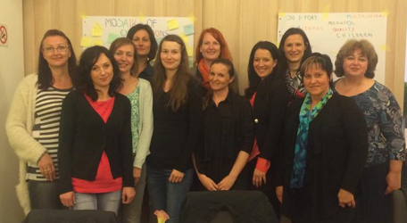
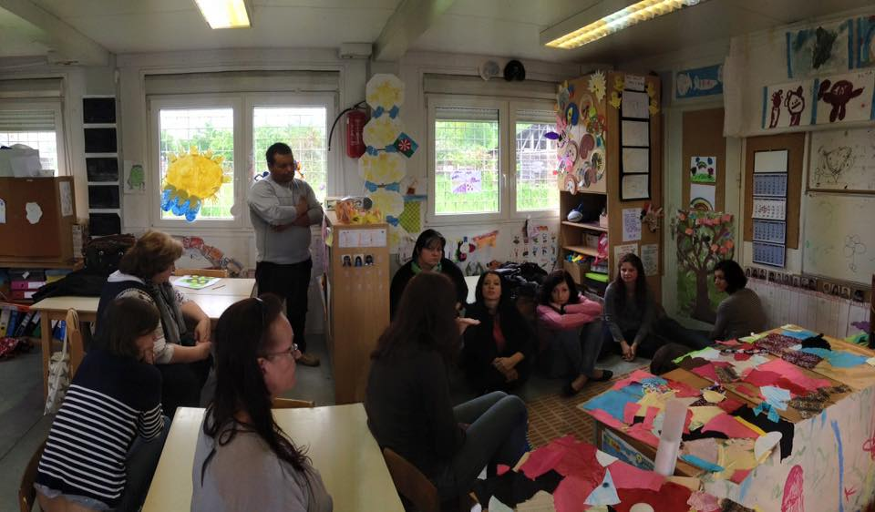
The training course was focused on following topics: Rationale for implementation of the Activities for children, who are not enrolled in preschool, and their parents:

- children's rights
- brain development
- social and economic factors
- Poverty
- social inclusion

- impact of quality ECEC for disadvantaged children, challenges
- Participation rates of Romani children in the education system and reasons for low participation rates
- Ensuring greater participation rates of Romani children in quality ECEC programs (Key principles of a Quality Framework for Early Childhood Education and Care, ISSA Quality Principles, Quality Framework for Early Childhood Practices in Services for Children Under Three Years of Age),
- Peer to peer learning on implementation of the Activities for children, who are not enrolled in preschool, and their parents, focusing on target groups, information campaign, aims and goals, forms and contents, benefits for children, parents and professionals, and challenges.

Presentations of linguistical, cultural and developmentally-appropriate multilingual material for children (picture books) developed so-far by partner countries and identification of possible uses for picture books in implementation of the Activities for children, who are not enrolled in preschool, and their parents were also part of the training course as well as joint development of guidelines for implementation of the Activities for children, who are not enrolled in preschool, and their parents,. These were based on discussions and presentations by all the participants. During the training course we had also meetings with representatives of Government of the Republic of Slovenia – Office for National Minorities, Preschool Kekec Grosuplje, Center for School and Outdoor Education and Preschool Šentvid (local project partner).
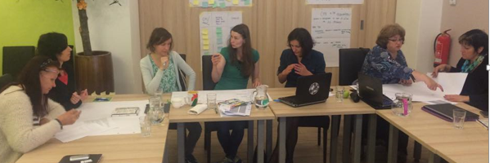

At the end of the training course, each partner organization designed an action plan that will ensure the transfer of the newly acquired content and information directly into their practice and context. In the project partnership we are convinced that meetings at the international level and training by providing information and expert discussions are not sufficient to transfer in-depth testing and adaptation of the new information and skills. Training, which is created on the basis of carefully collected and documented needs and followed carefully designed action plan can provide the opportunities and create conditions for achieving results.

Our conclusion: happy to share our experiences, examples of good practice and personal challenges! We are on a good way and KHETAUN we can do more!

Samanta Baranja, researcher
Developmental Research Center for Pedagogical Initiatives
Step by Step at Educational Research Institute Slovenia

